**Department of Computer Science and Engineering**

|  |  |
| --- | --- |
| **Course Code: CSE341** | **Credits: 1.5** |
| **Course Name: Microprocessors** | **Semester: Fall’18** |

**Lab 11  
Configuring EMU/MDA8086 Trainer Kit**

1. **Topic Overview:**

This lab is designed to introduce students with configuration of the EMU/MDA8086 Trainer Kit.

1. **Lesson Fit:**

In order to do the lab with ease, the student must have completed:

* 1. Lab 10 ‘Introduction to EMU/MDA8086 Trainer Kit’

1. **Learning Outcome:**

After this lecture, the students will be able to:

* 1. Have knowledge on how to write basic codes using the kit.
  2. Get hands-on knowledge on incorporating the instructions.

1. **Anticipated Challenges and Possible Solutions**

None Yet

1. **Acceptance and Evaluation**

Students will show the problems to the instructor one by one after completion. Those who won’t be able to finish the assigned tasks in time will show them in the next class. There will be a short viva for the students who will show the finished tasks on the next day to check if they completed the tasks by themselves. A deduction of 30% will be there for late submission. The marks distribution is as follows:

Code: 50%

Viva: 50%

1. **Activity Detail**
   1. **Hour: 1  
      Discussion: Basic Operation:**On a power-up, following message will be displayed on a LCD.

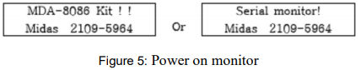

To use “Machine Code” mode, move jumper P1 which located on the PCB like this.

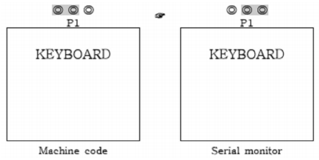  
Whenever RES is pressed, the display becomes Figure 5 and user can operate keyboard only in this situation.



HEXA-DIGIT KEY: Substitute to segment & offset address.

Example 1: Check the contents in memory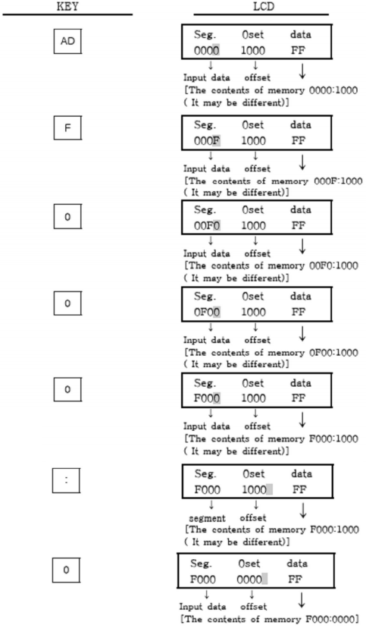



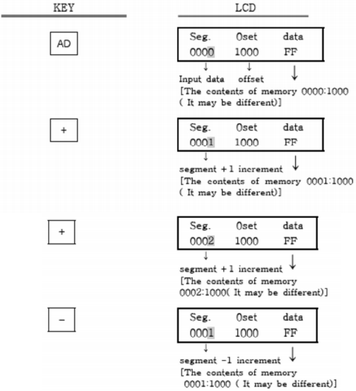



Example 2: Let's store the following like to 01000H ~ 01003H contents.

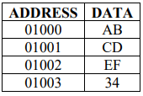

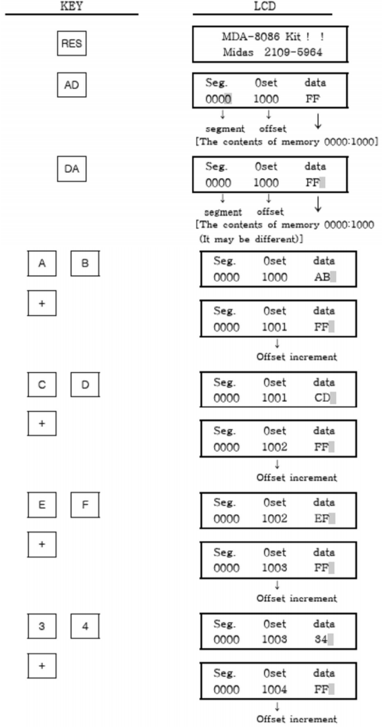

Example 3: Display the register contents.



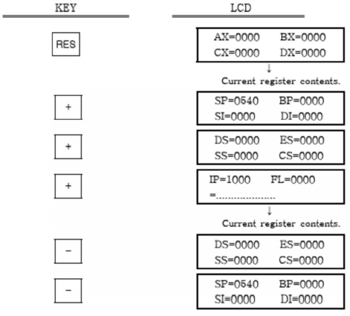

**Lab Exercise:** Store the following date to the specified memory location: 